COMPUTER PROGRAMING

EX NO -2

Name: Kakavakam Jaswanth Sai

Roll no: CH.EN.U4CSE20130

Section: CSE-B

Subject code: 19CSE102 LAB

EX NO -1 SIMPLE C PROGRAMS

1. SIMPLE INTEREST.

Aim:

To write a C program for calculating Simple interest.

Algorithm:

Step 1: Start

Step 2: Declare Three Floating values P (Principal Amount),N(Time Period of the Loan/Deposit in years) , R(Rate of interest) & SI(Simple interest).

Step 3: Input the values of P, N & R.

Step 4: Calculate (P\*N\*R)/100

Step 5: Store the out put of step4 to “SI”.

Step 6: Print SI.

Step 7: Stop

Program:

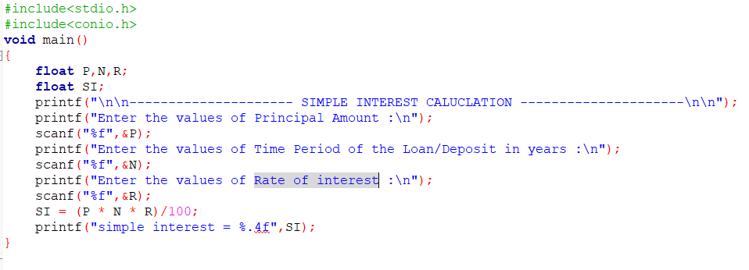

Output:

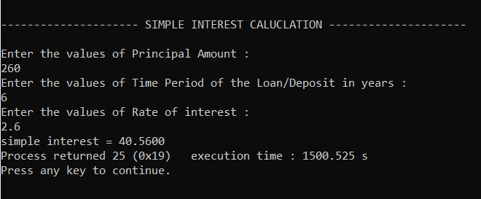

Result:

Thus the program to calculate the simple interest in C language has been executed and verified successfully.

1. GCD OF TWO NUMBERS

Aim:

To write a C program for calculating GCD of two Numbers.

Algorithm:

Step 1: Start

Step 2: Declare two integers a & b.

Step 3: Get the values of a & b.

Step 4: While a is not equal to b

Step 5: if (a>b) Calculate a-b and store to a

Step 6: else Calculate b-a and store to b

Step 7: END While

Step 8: Print b.

Step 9: Stop

Program:

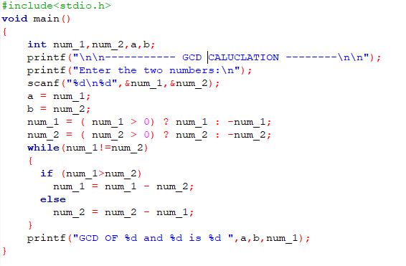

Output:

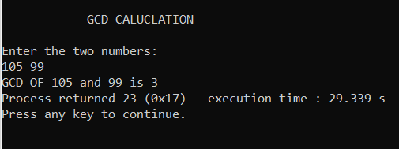

Result:

Thus the program to calculate the GCD of two Numbers in C language has been executed and verified successfully.

C. Demonstration of ARITHMETIC OPERATORS.

Aim:

To write a C program for demonstration of Arithmetic operators.

Algorithm:

Step 1: Start

Step 2: Declare two integers a & b.

Step 3: Get the values of a & b.

Step 4: Add a and b

Step 5: Subtract a and b

Step 6: Multiply a and b

Step 7: Divide a and b

Step 8: Calculate Mod of a and b

Step 9: Print the values of step 4,5,6,7,8.

Step 10: Stop

Program:

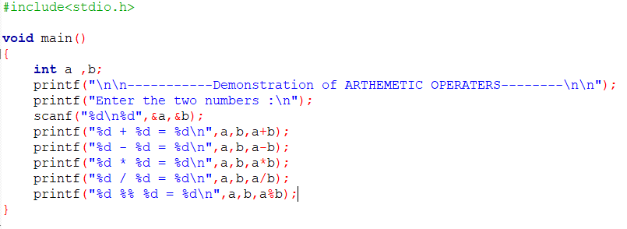

Output:

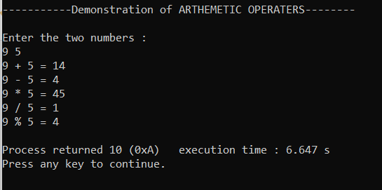

Result:

Thus the program to demonstration of Arithmetic operators in C language has been executed and verified successfully.

1. Demonstration of LOGICAL OPERATORS.

Aim:

To write a C program for demonstration of Logical operators.

Algorithm:

Step 1: Start

Step 2: Declare two integers a & b.

Step 3: Get the values of a & b.

Step 4: calculate the truth value of: a && b.

Step 5: calculate the truth value of: a || b.

Step 6: calculate the truth value of: !a or !b.

Step 7: Print the values of step 4,5,6.

Step 8: Stop

Program:

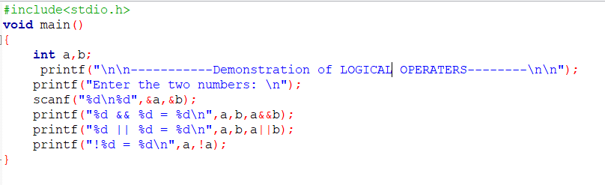

Output:

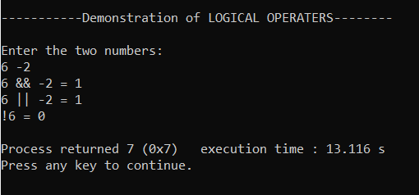

Result:

Thus the program to demonstration of Logical operators in C language has been executed and verified successfully.

1. Demonstration of INCREMENT& DECREMENT OPERATORS.

Aim:

To write a C program for demonstration of Increment & Decrement operators.

Algorithm:

Step 1: Start

Step 2: Declare two integers a & b.

Step 3: Get the values of a & b.

Step 4: Pre increment the a and print the value.

Step 5: Post increment the b and print the value.

Step 6: Print the new value of a and b.

Step 7: Pre decrement the a and print the value.

Step 8: Pre decrement the b and print the value.

Step 9: Stop.

Program:

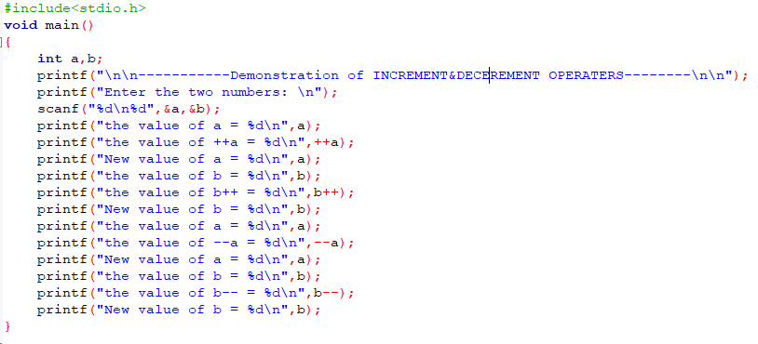

Output:

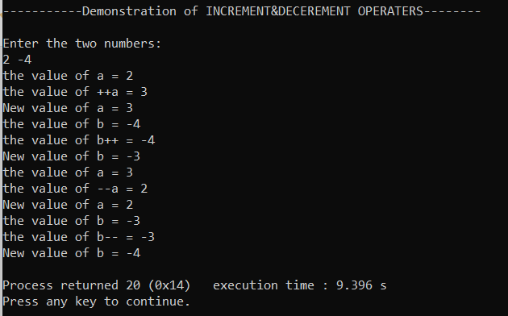

Result:

Thus the program to demonstration of Increment & Decrement operators in C language has been executed and verified successfully.

1. Demonstration of RELATIONAL OPERATERS.

Aim:

To write a C program for demonstration of Relational operators.

Algorithm:

Step 1: Start

Step 2: Declare two integers a & b.

Step 3: Get the values of a & b.

Step 4: Print the truth value of: a > b.

Step 5: Print the truth value of: a < b.

Step 6: Print the truth value of: a >= b.

Step 7: Print the truth value of: a <= b.

Step 8: Print the truth value of: a == b.

Step 8: Print the truth value of: a != b.

Step 9: Stop.

Program:

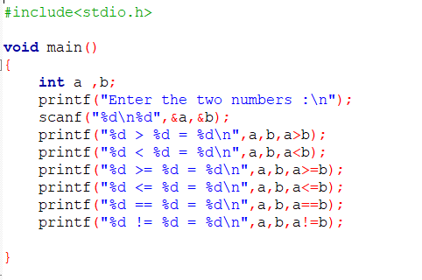

Output:

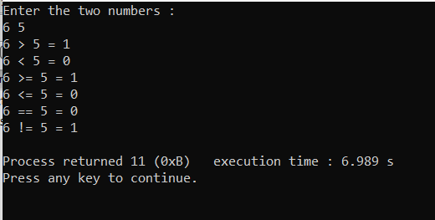

Result:

Thus the program to demonstration of Relational operators in C language has been executed and verified successfully.

1. Demonstration of ASSIGNMENT OPERATERS.

Aim:

To write a C program for demonstration of Assignment operators.

Algorithm:

Step 1: Start

Step 2: Declare two integers a & b.

Step 3: Get the values of a & b.

Step 4: Calculate the value of a += b and print the value of a,b,a += b.

Step 5: Calculate the value of a -= b and print the value of a,b,a -= b.

Step 6: Calculate the value of a /= b and print the value of a,b,a /= b.

Step 7: Calculate the value of a \*= b and print the value of a,b,a \*= b.

Step 8: Calculate the value of a %= b and print the value of a,b,a %= b.

Step 9: Stop

Program:

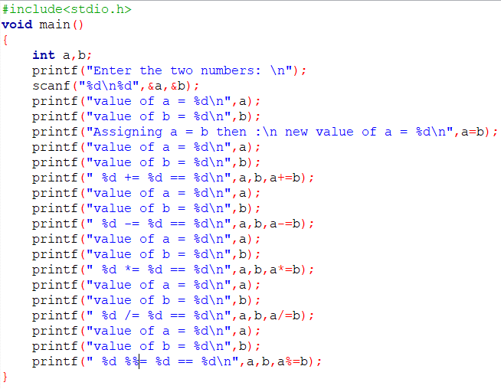

Output:

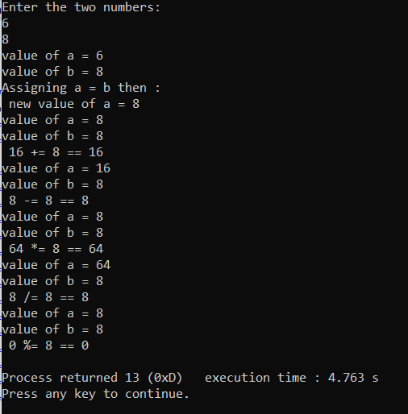

Result:

Thus the program to demonstration of Assignment operators in C language has been executed and verified successfully

1. Demonstration of CONDITIONAL OPERATER.

Aim:

To write a C program for demonstration of Conditional operators.

Algorithm:

Step 1: Start

Step 2: Declare two integers a , b &c.

Step 3: Get the values of a & b.

Step 4: Calculate (a>b) ? a : b.

Step 5: Store the value of step4 to c.

Step 6: Print the value of c.

Step 7: Stop

Program:

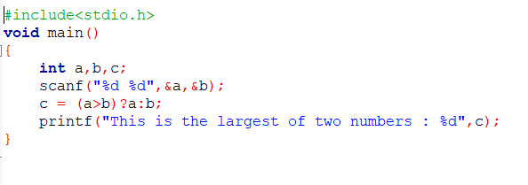

Output:

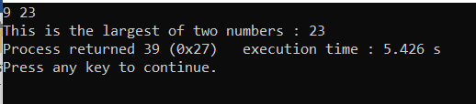

Result:

Thus the program to demonstration of Conditional operators in C language has been executed and verified successfully